To view a list of projects under your General Ledger String-
Log onto https://my.rutgers.edu
Click on Financial Management (Oracle Cloud) 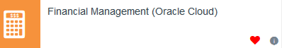
Click on Tools- and then Reports and Analytics 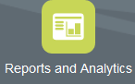
Click on the following path-
All Folders - Shared Custom RU Custom Reports PGM Reports RU PJ COA Segment Listing for Project Reports.xdo
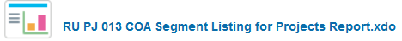
This will open up the selection criteria-
Select your project organization (which is your unit, division, organization as 1 number)
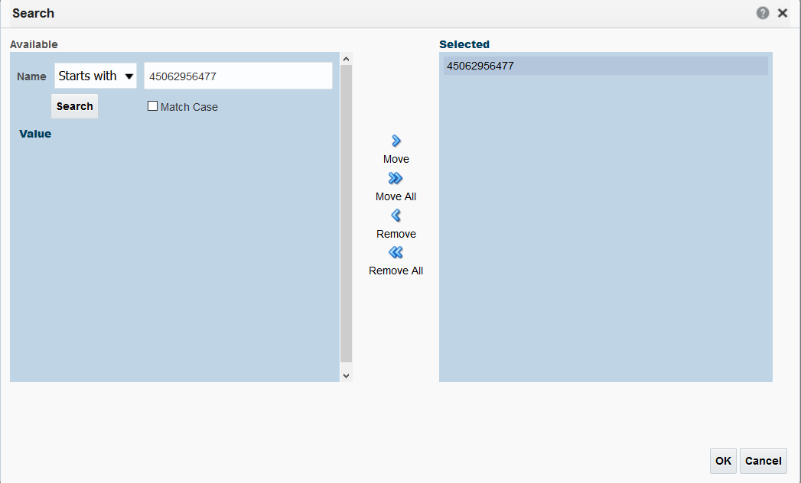
Once you have selected your project organization, click ok- then click apply to run your report.
The report will open in an excel and will list all projects under that project organization (UDO)
