To Access General Ledger Reports (GL)-
Log into Cornerstone: https://my.rutgersedu
Click on Financial Management (Oracle Cloud) 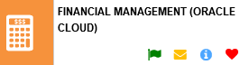and click on the Financial Reporting Center Icon- 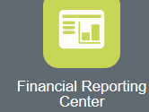
You will see a search bar on top of the screen-
You can enter your search here. Please note- in order for the reports to appear, you will need to click on “ALL” first-
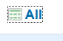
Enter in the number of your report, when it appears, you just click on the report name to find the report-
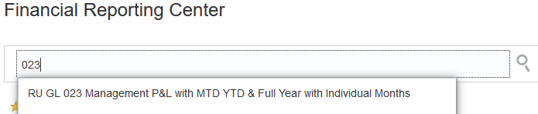
Once you find the report, you will need to click on the report name to get to the parameters-
Make sure that you allow pop ups, so you can enter your parameters!

