GL to Project Transaction Job Aid-
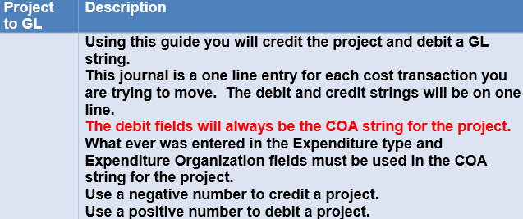

Log onto https://my.rutgers.edu, click on 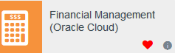
Click on the “Projects” icon and then the “Costs” icon
From the “task” icon select “Capture Costs” from the menu list and then click on “Create Nonlabor Costs”-
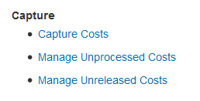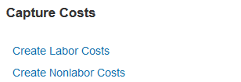
Click on “OK” to open up the excel spreadsheet, and logon with your net id and password.
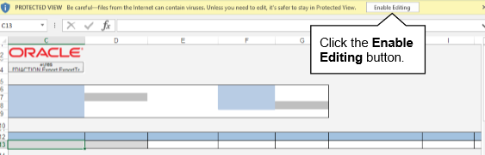

From the batch section-
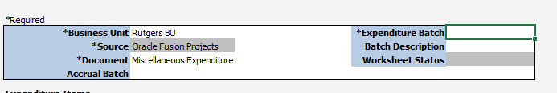
- Business Unit- Select Rutgers BU
- Source- leave as “Oracle Fusion Projects”
- Document- Select Miscellaneous Expenditure
- Expenditure Batch- enter in your batch name
Move down to your entry- this will be a 1 line entry
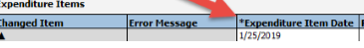 Expenditure Item date is date of transfer
Project name, project number, task name, task number are the project and tasks associated with the project that you are debiting.
If you do not know the exact spelling/spacing of your project, it is best you search for the information by double clicking on the cell.
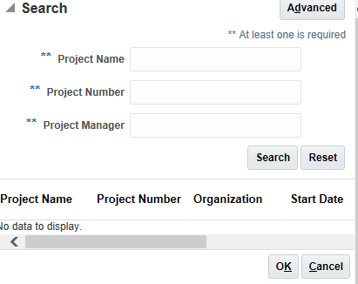
Enter your project number, click on ‘search’- this will bring up your project. Highlight the project and click ok. This will populate both the project number and project name in your spreadsheet.
If you do not know the exact spelling/spacing of your task, it is best you search for the information by double clicking on the cell.
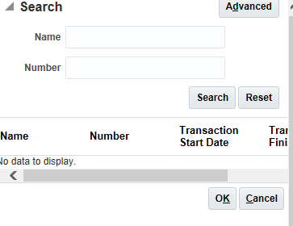
Enter your task number, click on ‘search’- this will bring up your task. Highlight the task and click ok. This will populate both the task number and task name in your spreadsheet.
Enter your “Expenditure Type” in the spreadsheet. “Expenditure Type” is the account code where the transfer will be recorded-
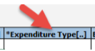
Enter the “Expenditure Organization” of the project you are using The “Expenditure Organization” is the Unit, Division, and Organization as 1 number.
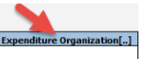
In the “Quantity” field, enter the dollar amount as a negative value. The project will be credited.
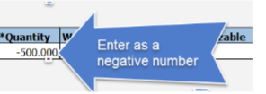
In the “Unmatched Negative Item” cell, select “Yes” from the drop down menu
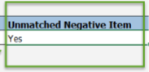

Enter your “Expenditure Comments” This should be a description of the transfer and will appear on the project reports.
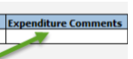

Fill in the “Raw Cost Debit Account” and the “Raw Cost Credit Account” In the “Raw Cost Credit Account” enter the GL string you are debiting.
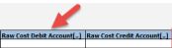
If you are having issues with formatting your string, you can search on it, by double clicking on the cell underneath the Raw Cost Debit Account or the Raw Cost Credit Account. Click on the search icon-
Type in your numbers, and when you are done, click on OK to see the string, then click on OK to add to your spreadsheet
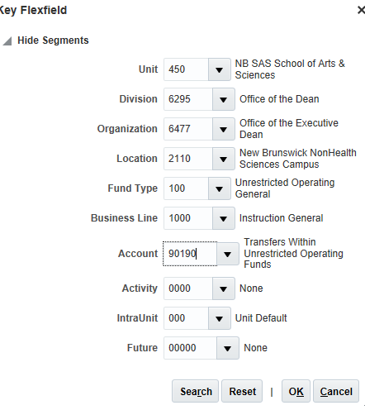
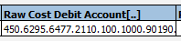
When you are done with your entry, you will need to export it to your approver-
