Account Analysis-
The Account Analysis tool is another option to see activity in your general ledger.
To access- log onto https://my.rutgers.edu
Click on “Financial Management (Oracle Cloud)”
Click on “Tools” and then Click on “Scheduled Processes”
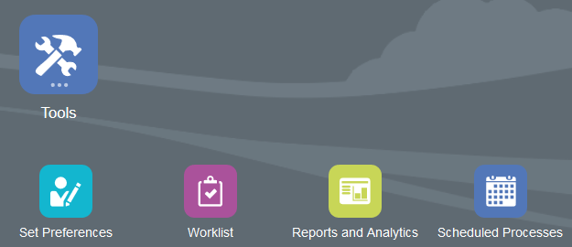
Click on “Schedule New Process” from the “Overview” screen:
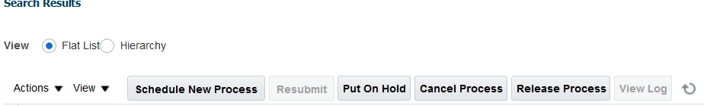
This will bring up the search menu- search for “Account Analysis” (it is case sensitive)
Select “Account Analysis Report” and click “OK”
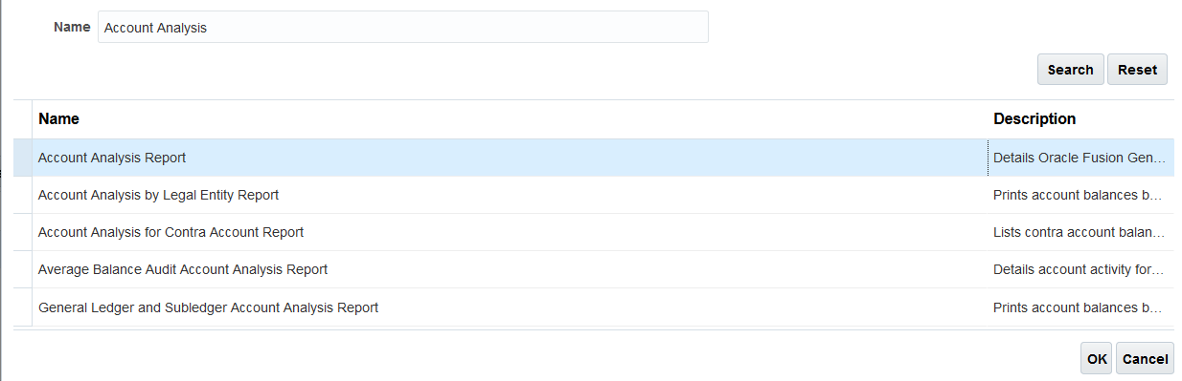
Click “OK” again to get to the “Process Details” pop up-
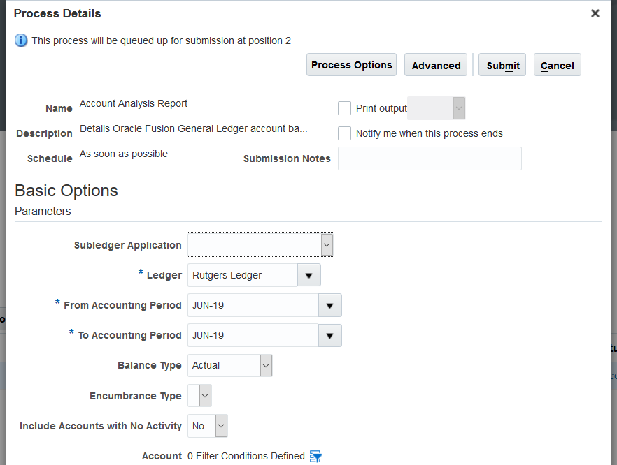
Click on the filter to select your string

Balance type remains “Actual”

Select the period you want to view

Sub ledger Application should be blank (you can select from drop down menu)

You will need to add fields:
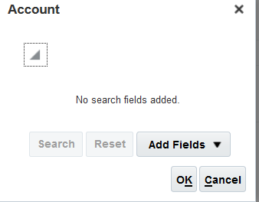
This will open up the search criteria to select

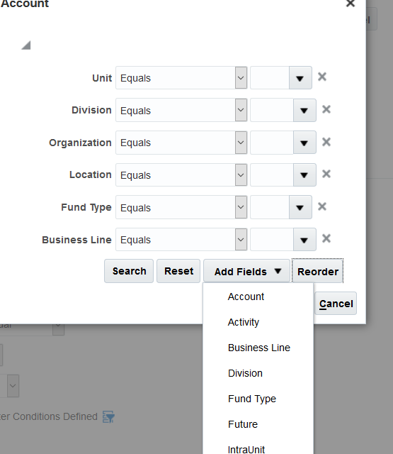
You can enter your string here.

Quick Tip: If you want to see all of your activity between your GL and your non-specific projects used for operation (Summer Session Project, ICR project) and you use the same business line for all of your operational purchases, you can change your fund type to “between” 100-150 and limit your business line to “1000” (if that is the string that you use)

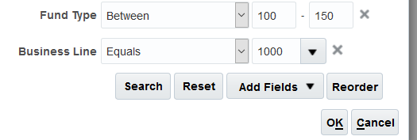

Click on “OK”, this will bring you back to the “Process Details” screen. Click on “Advanced” to get to the Advanced Options screen. Click on “Output”
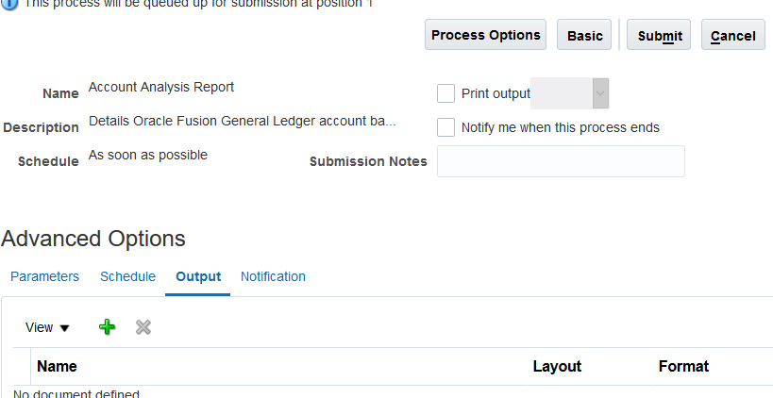
Click on the “+” sign-
From “Layout” make sure it says “RU GL 089 Account Analysis Report” and format should be “Excel”. When that is done, click on “Submit”
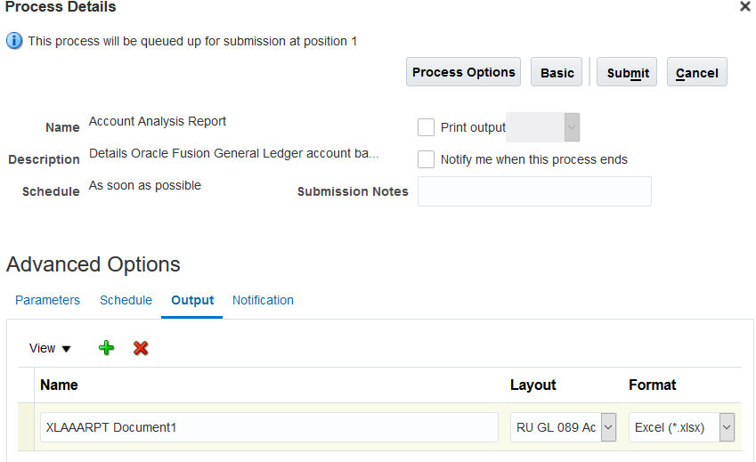
A confirmation for the report will pop up, click on OK. This will bring you back to the “Overview” screen. You will need to click on the refresh icon to see your report running.
Refresh icon

When the report is done running, it will say “succeeded” in the “Status” section
Click on the report and the “Output file will appear”
Click on the “Output Name” to open your report-
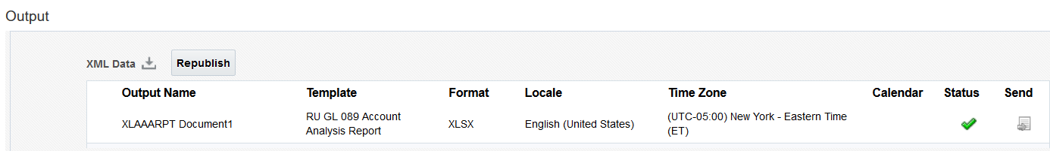
Click here to open the report “XLAAARPT…”
This will open up your report in excel-
You will be able to view your data based on the criteria you selected:
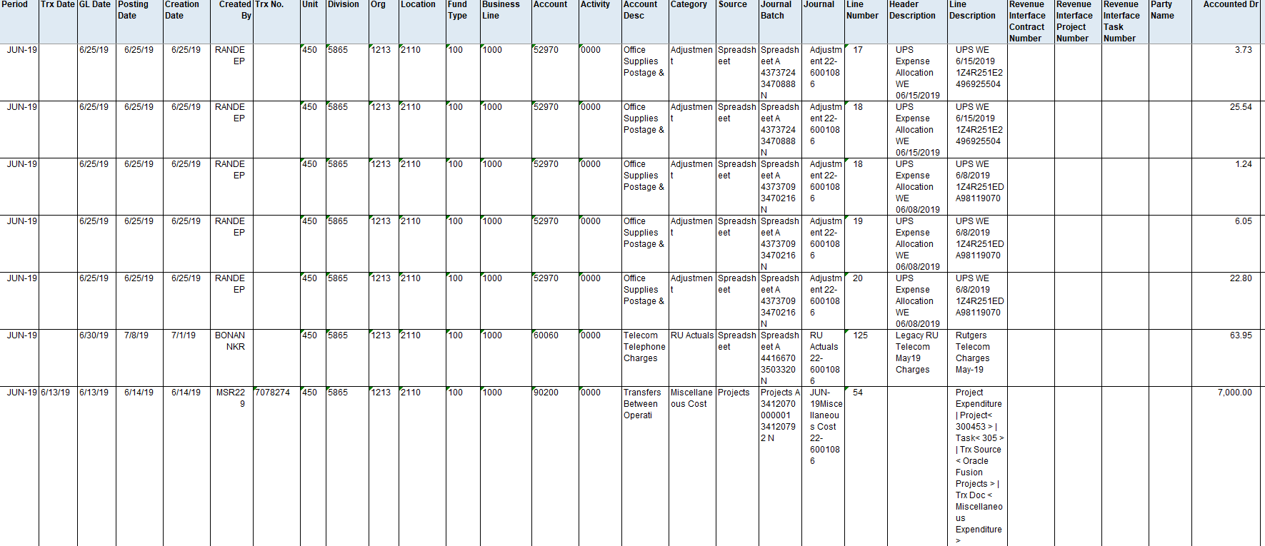
You can run this report for any string you select.

